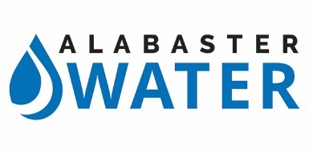
FOR IMMEDIATE RELEASE December 14, 2018

UPDATED – 12:00 PM

Boil Water Notice Rescinded and Lifted for All Alabaster Residents

Alabaster, AL – The BOIL WATER NOTICE issued by the Alabaster Water Board on December 12, 2018 has been RESCINDED and LIFTED effective 12:00 PM Friday, December 14, 2018. Bacteriologic testing conducted on December 13, 2018 was negative for bacteria.
The boiling of water in the affected area is no longer required. All water in Alabaster is safe to drink and cook with from the tap.
For residents who have questions, please contact Alabaster Water at 205-663-6155.

